EXPERIMENT NO : 2

FRIENDSHIP:
friend(nunew,zee).
friend(joke,pond).
friend(diya,siya).
friend(siya,diya).
mutual_friend(X,Y):- friend(X,Y),friend(Y,X).
OUTPUT:
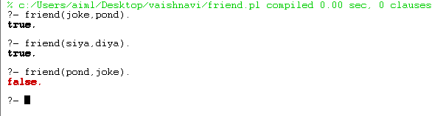

FACTORIAL :
factorial(0,1).
factorial(N,Result):-
N>0,
N1 is N-1,
factorial(N1 , Result1),
Result is N * Result1.

OUTPUT :
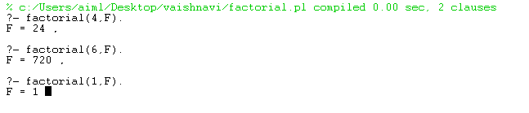
Celsius to Fahrenheit :
convert(C,F):-
F is 9*C/5+32,(C<0->write('it is freezing');write('it is not freezing')).
OUTPUT:
